Challenge Number: 1011
Played on date: April 15, 2022 Time: 12:30
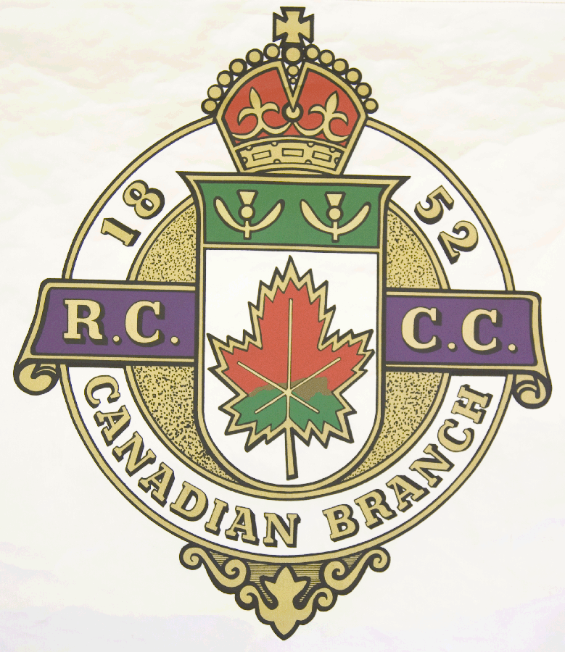
Hosting Club: Metcalfe Curling Club

Host Club Address: 2793 8th Line Road

Host Club City: Metcalfe, Ontario

Host Club Telephone: 613 - 821 - 2335

Host Contact Person: Bill Woods Sr.

Contact phone or email: bill.woods@sympatico.ca

Hosting Club: Metcalfe Challenging Club: Sherbrooke

Skip: WEW Woods Skip: Dominique Gilbert

Third: Don Chasse Third: Donald Boivin

Second: Kyle Hogan Second: André Beauregard

Lead: Terry Lantz Lead: Martin Arsenault

Skip: WJR Woods Skip: Jean Langevin

Third: Bill Carr Third: Simon Morrissette

Second: Brent Denison Second: Patrick Baril

Lead: Niall MacLean Lead: Louis Nadeau .

 | Skip | 1 | 2 | 3 | 4 | 5 | 6 | 7 | 8 | 9 | 10 | Score
Sheet  1 | WEW Woods | 0 | 3 | 3 | 0 | 0 | 2 | 0 | 1 | 0 | 2 | 11
Sheet  1 | Gilbert | 2 | 0 | 0 | 2 | 0 | 0 | 2 | 0 | 2 | 0 | 8
Sheet  2 | WJR Woods | 1 | 0 | 0 | 0 | 2 | 0 | 1 | 1 | 0 | 1 | 6
Sheet  2 | Langevin | 0 | 0 | 0 | 1 | 0 | 2 | 0 | 0 | 2 | 0 | 5

Hosting club score: 17____ Challenging club score: __ 13____

